**PRACTICAL 2**

**AIM:**

Write a simple Smart Contract, compile, deploy it using Metamask Ropsten Test Network

* Setting a Greeting —we should be able to set a greeting
* Displaying the Greeting —we should be able to retrieve the greeting and display it.

**CODE:**

pragma solidity 0.5.3;

contract TestContract{

string private greeting;

constructor() public{

greeting = "Hello Kashyap Shah!";

}

function setGreeting(string memory newGreeting) public {

greeting = newGreeting;

}

function greet() public view returns (string memory){

return greeting;

}

}

**OUTPUT:**

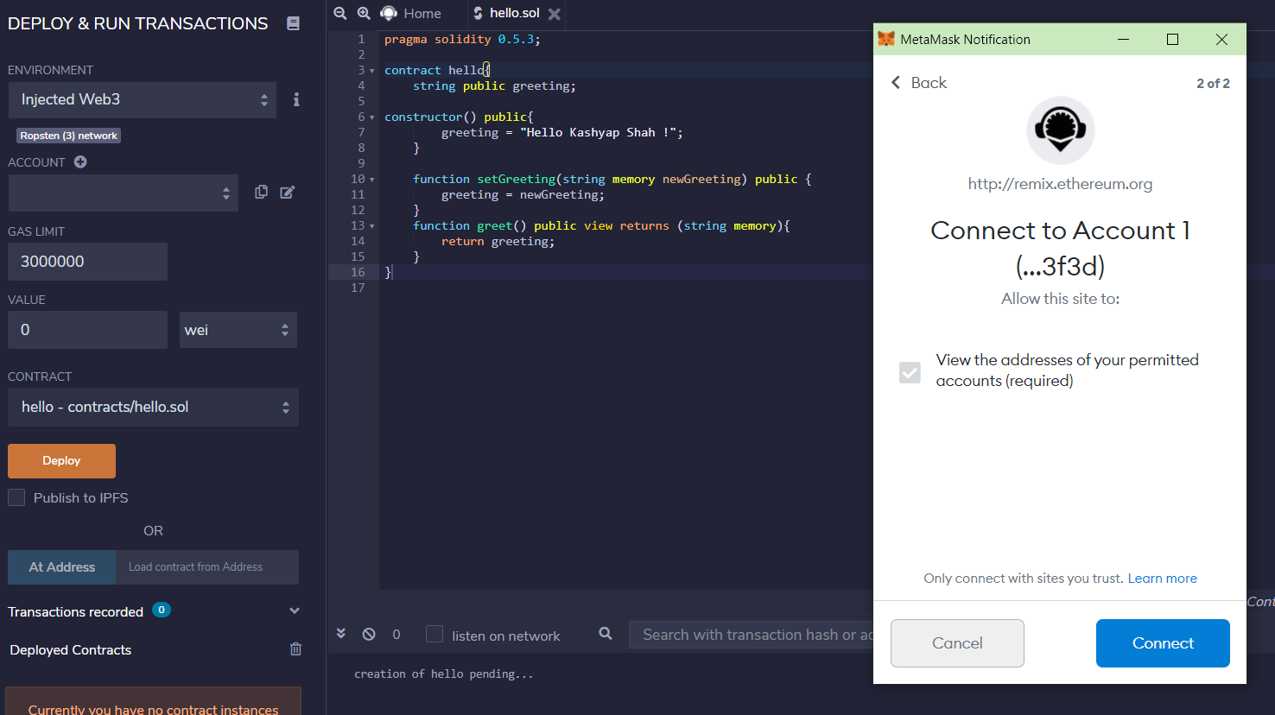

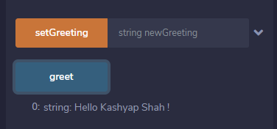

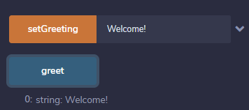

**CONCLUSION:**

In this practical, I have learnt about solidity programming, about functions and testing.